|  |  |  |  |
| --- | --- | --- | --- |
| Predictive Road Safety Modeling and Analysis with the IHSDM Optimization App (IOA) and Power BI Dashboards – User Manual  HDR Traffic Safety Practice Group  Updated: September 4, 2020 |  | |  |
|  |  |  |  |
|  |  |
|  |  | |  |
|  |  | |  |



Contents

1 Purpose and Need 1

1.1 Overview of IHSDM 1

1.2 Shortcomings of IHSDM 1

1.3 Objectives of IOA 2

1.4 Objectives of the Power BI Dashboards 2

2 Overview 1

2.1 Getting Started with IOA 1

2.2 IOA Modules 2

2.3 Getting Started with Power BI Dashboards 3

3 Predictive Safety Modeling with IOA 1

3.1 Terminology 1

3.2 Data Collection 1

3.2.2 Data Collection Template Spreadsheets 1

3.3 Importing Data 1

3.3.1 The “Import Data” Module 2

3.4 Exporting Horizontal Curve Data from CAD Alignments 1

3.4.1 The “Export Horizontal Curve Data from CAD Alignments” module 1

3.5 Evaluating Elements 1

3.5.1 The “Batch Evaluation” Module 1

3.6 Parsing HTML Evaluation Results 1

3.6.1 The “Parse HTML Results” Module 1

3.7 Analyzing Data by Segments for Freeways, Ramps, and Arterials 1

3.7.1 The “Segment Analysis for Freeways, Ramps, and Arterials” Module 1

4 Predictive Safety Analysis with Power BI Dashboards 1

4.1 Overview 1

4.2 Setting up the Dashboards 2

4.2.1 Files for the Dashboards 3

4.3 Model Analysis 4

Tables

Table 1. Modules of IOA 2

Table 2. Power BI Dashboard Templates 1

Figures

Figure 1. Blue Screen When First Running IOA 2

Figure 2. Predictive Modeling Process 1

Figure 3. Elements in IHSDM 2

Figure 4. Flexibility of the DCT Spreadsheets 3

Figure 5. Adding Alignments to “Alignment Master List” in DCT Spreadsheets 4

Figure 6. Multiple Rows of Data for Element in DCT Spreadsheets 5

Figure 7. Workflow of Importing CAD Alignments in IHSDM and Using the “Data Import” Module in IOA 1

Figure 8. The “Import Data” Module 2

Figure 9. DCT Spreadsheet Data to Imported IHSDM Element 3

Figure 10. Selected Data Attributes to Import File (File ID: B-1) 5

Figure 11. Selecting the IHSDM Project Folder 6

Figure 12. Element Name Prefix 7

Figure 13. Rotate Alignments by 90 Degrees using “Import Data” Module in IOA 8

Figure 14. The “Export Horizontal Curve Data from CAD Alignments” module 1

Figure 15. Excel File with Alignment Names (File ID: D-1) 2

Figure 16. Selecting the IHSDM Project Folder 3

Figure 17. Element Name Prefix 4

Figure 18. Windows Display Settings for Main Display 2

Figure 19. IHSDM Window Maximized with No Other Windows in Front 3

Figure 20. Only Elements in Immediate View Can Be Evaluated 3

Figure 21. Make Sure Elements Not Selected When Running Module 4

Figure 22. Select Type of Element to Evaluate 5

Figure 23. Index of First Element to Evaluate 6

Figure 24. Element Name Prefix 7

Figure 25. HTML or PDF Outputs Saved in Selected Folder After Batch Evaluation Complete 8

Figure 26. The “Parse HTML Results” Module 1

Figure 27. Each Table in HTML Files is a Tab in Parsed Excel File 2

Figure 28. Parsed Excel Files Created in the Same Folder as the HTML Files 3

Figure 29. The “Segment Analysis for Freeways, Ramps, and Arterials” Module 1

Figure 30. User-Defined Segmentation File 3

Figure 31. Output of “Segment Analysis for Freeways, Ramps, and Arterials” Module 4

Appendices

No table of contents entries found.

Acronyms and Abbreviations

|  |  |
| --- | --- |
|  |  |
|  |  |
|  | IOA = IHSDM Optimization App  IHSDM = Interactive Highway Safety Design Model  HSM = Highway Safety Manual  DCT spreadsheets = Data collection template spreadsheets  CAD = Computer Aided Design  QC = Quality Control |
|  |  |
|  |  |
|  |  |
|  |  |

# Purpose and Need

## Overview of IHSDM

The Interactive Highway Safety Design Model (IHSDM) is a software package developed by the Federal Highway Administration that allows users to create predictive safety models according to the Highway Safety Manual (HSM) methodologies.[1] In IHSDM, users create elements, add data that correspond to the data inputs in the HSM, and evaluate elements, producing crash prediction outputs in the form of HTML output results. The Wiki page for IHSDM can be found [here](https://www.ihsdm.org/wiki/Welcome).

## Shortcomings of IHSDM

While IHSDM is a significant advancement in how the HSM predictive method is applied, some drawbacks limit the efficiency of building models in the software. The following three shortcomings are most apparent:

* Data must be manually typed (or copied) in for each element, one at a time. To enter input data to the model, users must open each element individually and edit the data through a graphical user interface (GUI). This can become cumbersome for large models, such as urban freeway networks that include ramps and ramp terminals.
* To evaluate the model, each element must be evaluated separately. No batch process allows the user to simply evaluate all elements in the model with a few clicks. On average, it takes 30 seconds to evaluate each element and save/name the output. For large models, evaluations can take multiple hours for each scenario.
* The crash prediction outputs produced in IHSDM can be in the form of HTML, PDF, or a spreadsheet. HTML results cannot be directly analyzed and must be copy/pasted into a spreadsheet. PDF is not a format conducive to analysis or parsing and is primarily a visual format. The spreadsheet output is not an easily analyzed table. Rather, it includes headers above the data that must be cleaned before analysis. Furthermore, one crash prediction output is produced per element. To evaluate the model as a system, the individual prediction outputs must be combined. This can be a significant manual effort.
* IHSDM cannot summarize input or output data according to user-specified segments. The program creates homogeneous segments consistent with HSM methodologies, but these can vary widely in length. Often, it is desirable to analyze input and output data according to segments determined by gore points on freeways, or segments of a consistent length (e.g., segment every 0.25 miles).

## Objectives of IOA

The IHSDM Optimization App seeks to streamline some of the more onerous processes involved with predictive safety modeling in IHSDM. In particular, the app aims to:

* Improve the process by which data are inputted to the IHSDM elements.
* Develop a process to batch evaluate elements in IHSDM.
* Streamline the process for converting the ISHDM crash prediction outputs into outputs that can be easily analyzed.
* Synthesize input and output data according to user-specified segments

## Objectives of the Power BI Dashboards

With a standardized crash prediction output, dashboards are an optimal solution for automated data visualization and analysis. Since the format of the prediction outputs does not change, dashboards can be created that allow for the seamless import of new data. The objectives of the dashboards are:

* Automating data visualization and analysis of crash prediction outputs
* Expanding the breadth of analysis techniques
* Promoting multivariate analysis of the relationships between model inputs and crash prediction outputs

# Overview

IOA is an application built in the programming language Python[2] with a graphical user interface developed in Qt Designer[3]. The application is converted from the Python interpretive language into an executable file (.exe) to run on any user’s computer without having to install Python.

Because IOA uses a graphical user interface, no programming or coding skills are necessary to use the app. All the logic and processes are completely hidden from the end-user to avoid confusion or complication. The app was designed to be as user friendly as possible with widgets to select and upload files.

All the resources for IOA are housed on the Traffic Safety Practice Group Sharepoint site [here.](https://hdrinc.sharepoint.com/:f:/r/teams/TrafficSafetyPracticeGroup/Shared%20Documents/5.%20Tools%20%26%20Spreadsheets/IHSDM%20Optimization%20App?csf=1&web=1&e=MkL2Cq)

## Getting Started with IOA

To download IOA, go to the OneDrive folder [here](https://hdrinc-my.sharepoint.com/personal/sklump_hdrinc_com/_layouts/15/onedrive.aspx?id=%2Fpersonal%2Fsklump%5Fhdrinc%5Fcom%2FDocuments%2FApps%2FIHSDM%20Optimization%20App%2Fdist%2FApp%5FDist%5FFolder&originalPath=aHR0cHM6Ly9oZHJpbmMtbXkuc2hhcmVwb2ludC5jb20vOmY6L3Avc2tsdW1wL0V2ZEI5emFyRjVSSnZGaVpoSWVPS280QlVtNnFHSXRPWm1MX1VZQVhVZDZ1SEE_cnRpbWU9dGk3dk1VMUoyRWc). If this is the first time accessing the folder, please request access by emailing Sam Klump at [samuel.klump@hdrinc.com](mailto:samuel.klump@hdrinc.com). Then follow these steps:

1. Download the “IOA.zip” folder to your local machine (download time: 2-4 minutes)
2. “Extract All…”
3. Within the extracted folder, there are two folders, named “PNG Files” and “UI Files”, and an “Application.exe” file. All are needed to operate the app.
4. Double-click “Application.exe” to run the app.
5. The first time running IOA, a blue screen titled “Windows protected your PC” will appear (Figure 1). Click “More info” (red arrow in Figure 1). Then click “Run anyway”.

Figure 1. Blue Screen When First Running IOA

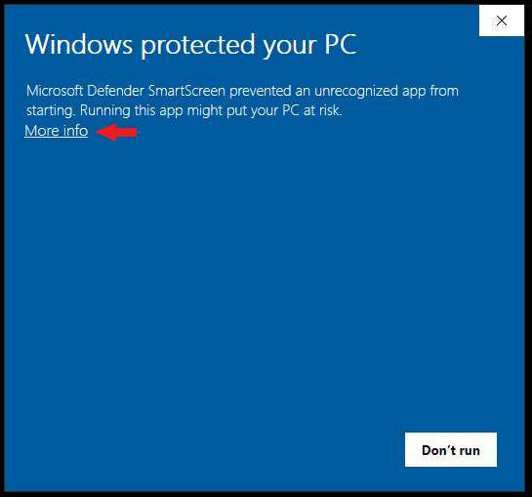

Note there is a ~10-second start-up delay for IOA. Once running, there is no delay in the app.

Once downloaded, IOA can be pinned to the user’s taskbar, if desired. After double-clicking “Application.exe” to run, simply right click on the IOA icon and click “Pin to taskbar”.

## IOA Modules

There are five main modules (processes) in IOA. The module names, short descriptions, and links to sections within this user manual are shown in Table 1.

Table 1. Modules of IOA

| **Module Name** | **Description** | **Link to Section in User Manual** |
| --- | --- | --- |
| **Import Data** | Imports data from standardized Excel input-data-templates directly into IHSDM. | Section 3.3 |
| **Export Horizontal Curve Data from IHSDM** | Exports horizontal curve/tangent data from alignments imported into IHSDM into Excel spreadsheet | Section 3.4 |
| **Batch Evaluation** | Controls user’s mouse and keyboard to run evaluations. | Section 3.5 |
| **Parse HTML Results** | Scrapes data from HTML reports into a compiled Excel spreadsheet. | Section 3.6 |
| **Segment Analysis for Freeways, Ramps, and Arterials** | Compiles input and crash output data by user-defined segments (e.g., interchange to interchange) | Section 3.7 |

## Getting Started with Power BI Dashboards

Power BI is a free desktop application developed by Microsoft that has three main functions: data modeling (i.e., creating relationships between data), data transformation, and multivariate data visualization. Power BI can be thought of as a package that incorporates the database capabilities of Microsoft Access and the visualization capabilities of Pivot Tables in Microsoft Excel.

Power BI can be installed free of charge and without IT assistance [here](https://powerbi.microsoft.com/en-us/desktop/). It can also be accessed through the Microsoft Store.

# Predictive Safety Modeling with IOA

The overall predictive safety modeling process with IOA is shown in Figure 2. In Steps 1-3, data are collected in standardized spreadsheets and imported into IHSDM elements. Step 4 is optional, involving exporting horizontal curve data from imported alignments into spreadsheets for ease of analysis. In Steps 5-7, model evaluations are run, HTML results are parsed into Excel files, and input/output data are synthesized for user-defined segments. Finally, input data from Step 1 and the output files created in Steps 6 and 7 are imported to Power BI dashboard templates, completing the process.

Figure 2. Predictive Modeling Process

## Terminology

In this manual, the term “element” refers to sites for analysis in IHSDM. In Figure 2, the red arrow points to an element.

Figure 3. Elements in IHSDM

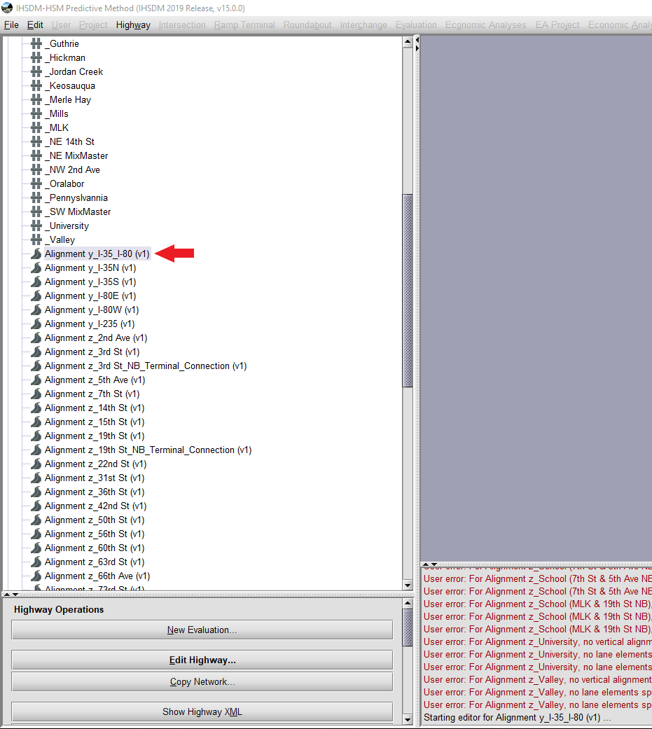

## Data Collection

Data for IHSDM models can be stored either directly in IHSDM or stored in Excel spreadsheets and subsequently imported into IHSDM. IOA makes use of data collection in spreadsheets, in general, because the safety analyst is much more restricted when data are stored in IHSDM. Input data should be statistically analyzed to catch errors. The input data drives the models and thus the analysis. Errant input data produce errant model outputs. More specifically, the following are reasons to store data in spreadsheets as opposed to in IHSDM:

* Analysis of model input data is not possible when stored in IHSDM, whereas the full suite of analysis tools in Excel can be used when data are stored in spreadsheets. For example, an average shoulder width in a network cannot be computed in IHSDM, whereas this can be determined very quickly with simple equations in Excel.
* Visualization of input data is not possible in IHSDM. Visualization can help catch errors in the input data, for example by using box and whisker plots to identify potential outliers.
* Data collected in spreadsheets can be QC reviewed easier and faster than in IHSDM, due to having the full range of Excel capabilities.
* Analysis of input data drives actionable insights. Questions such as “which ramps in my network have shoulder widths below 5’?” cannot be answered when data are stored in IHSDM, whereas this can be achieved in Excel with simple filters.
* Spreadsheets can be stored and reviewed by anyone on ProjectWise, whereas data in IHSDM can only be viewed by those with IHSDM installed. If stored in IHSDM, models must be archived and uploaded to ProjectWise.

##### Use of CAD Alignments

Though not required for use of IOA, using CAD alignments for stationing references is recommended as they form an objective and constant reference for location data. If data are to be collected in Google Earth, CAD alignments can be converted to KMZ files and be overlaid on aerial photography. This creates a traceable record of how data were collected and increases the ease and quality of QC reviews.

### Data Collection Template Spreadsheets

IOA uses data collection templates that have a standardized format for which data can be seamlessly imported into IHSDM (in the “Import Data” module). The templates are formatted with the same column names as in IHSDM with the same data restrictions. Throughout this manual, these data collection template spreadsheets are referred to as “DCT spreadsheets”.

The DCT spreadsheets include all possible data that can be inputted in IHSDM. There is no need to fill out the DCT spreadsheets in their entirety. The data inputs included in the models should be discussed with the analysis team based on schedule, budget, and desired precision. For example, freeway data for the “High Volume Section” tab may not be available or desired in the models, and if so, may be left blank. However, some data are required for evaluations in IHSDM. For example, lane data must be collected/stored/inputted for ISHDM to run a freeway evaluation. Modelers should review the Highway Safety Manual (HSM) for what data are required versus optional for the applicable facility type.

#### Requirements for DCT Spreadsheets

The DCT spreadsheets were designed to be as flexible and non-restrictive as possible. However, one rule must be adhered to:

* Do not change the data restrictions in the tables. When copy/pasting data, use “paste as values”, to not copy formats over any data restrictions.

Also, the following password-protected restrictions are in place:

* The column names in any tables cannot be changed. However, columns can be added to the tables.
* Tabs cannot be deleted, added, or have their names changed. If data are not needed for a tab, simply leave it blank.

If the above rules are adhered to, users have the flexibility to modify the DCT spreadsheets in any way they wish, including, but not limited to (see Figure 4 for illustration):

* Equations, formatting, and notes may be added to any of the tables.
* Columns may be added to the tables
* Notes/text/calculations can be added to any cells
* Files can be named anything, though it is recommended a unique descriptive name is given for good file management practices.

Figure 4. Flexibility of the DCT Spreadsheets

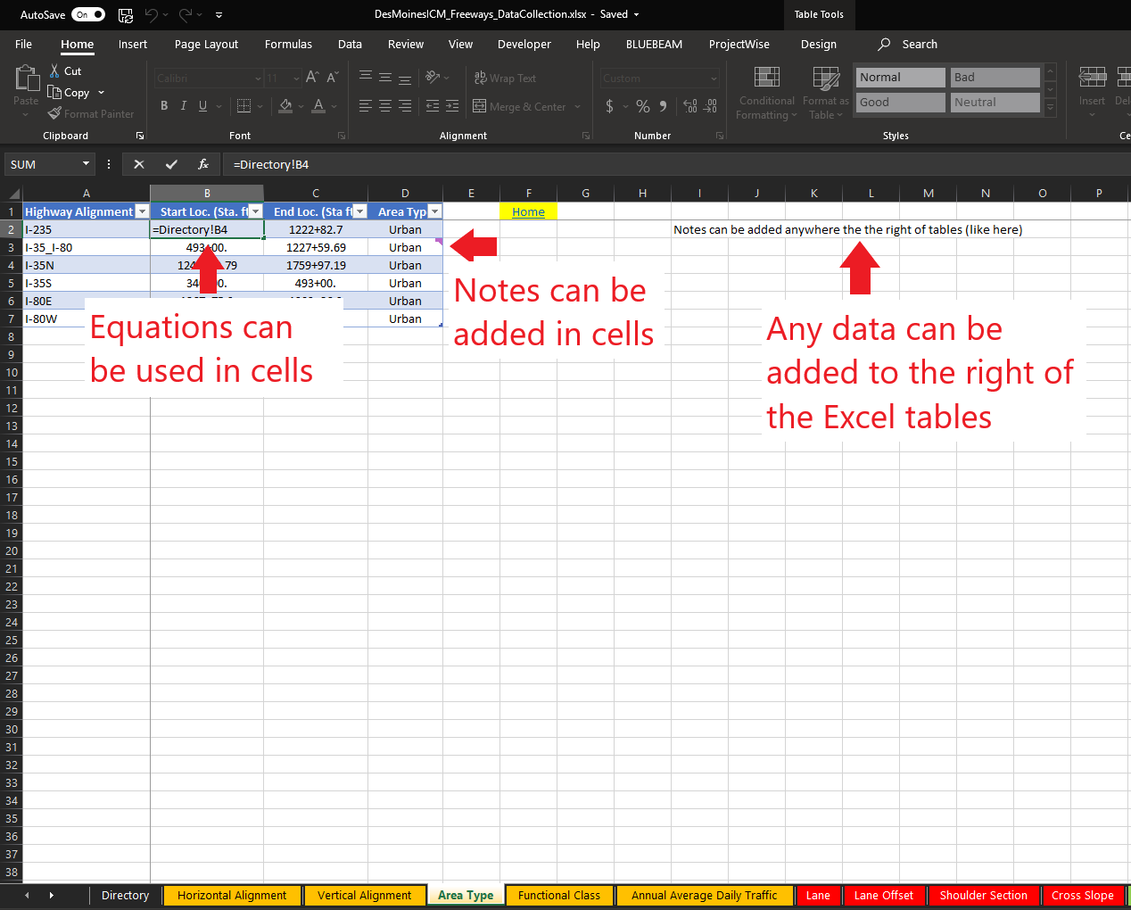

#### Getting Started with the DCT Spreadsheets

Before entering any data in the DCT spreadsheets, add the alignments and their corresponding start and end stations to the “Alignment Master List” in the “Directory” tab, as shown in Figure 4. Note the stations in all tabs in the DCT spreadsheets are formatted with the “+” sign, but they are decimal numbers in the cells, so do not manually add in the “+” sign (the data restrictions won’t allow this, regardless).

Figure 5. Adding Alignments to “Alignment Master List” in DCT Spreadsheets

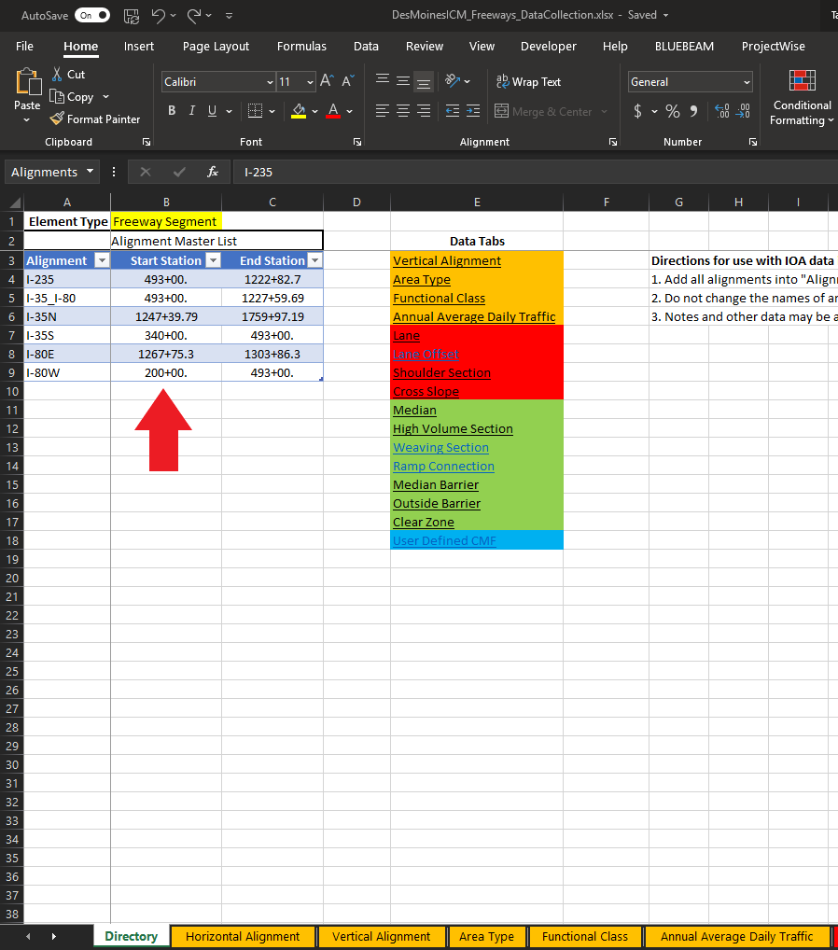

In each tab in the DCT spreadsheets, the first column is “Highway Alignment.” This is the element name for which the data in the corresponding row are associated. An element may have multiple rows of data in each tab. For instance, Figure 6 shows how multiple rows of lane data are added for the “I-235” element.

Associate each row of data in the DCT spreadsheets to the element that the row corresponds to by typing in the element name in the “Highway Alignment” column.

Figure 6. Multiple Rows of Data for Element in DCT Spreadsheets

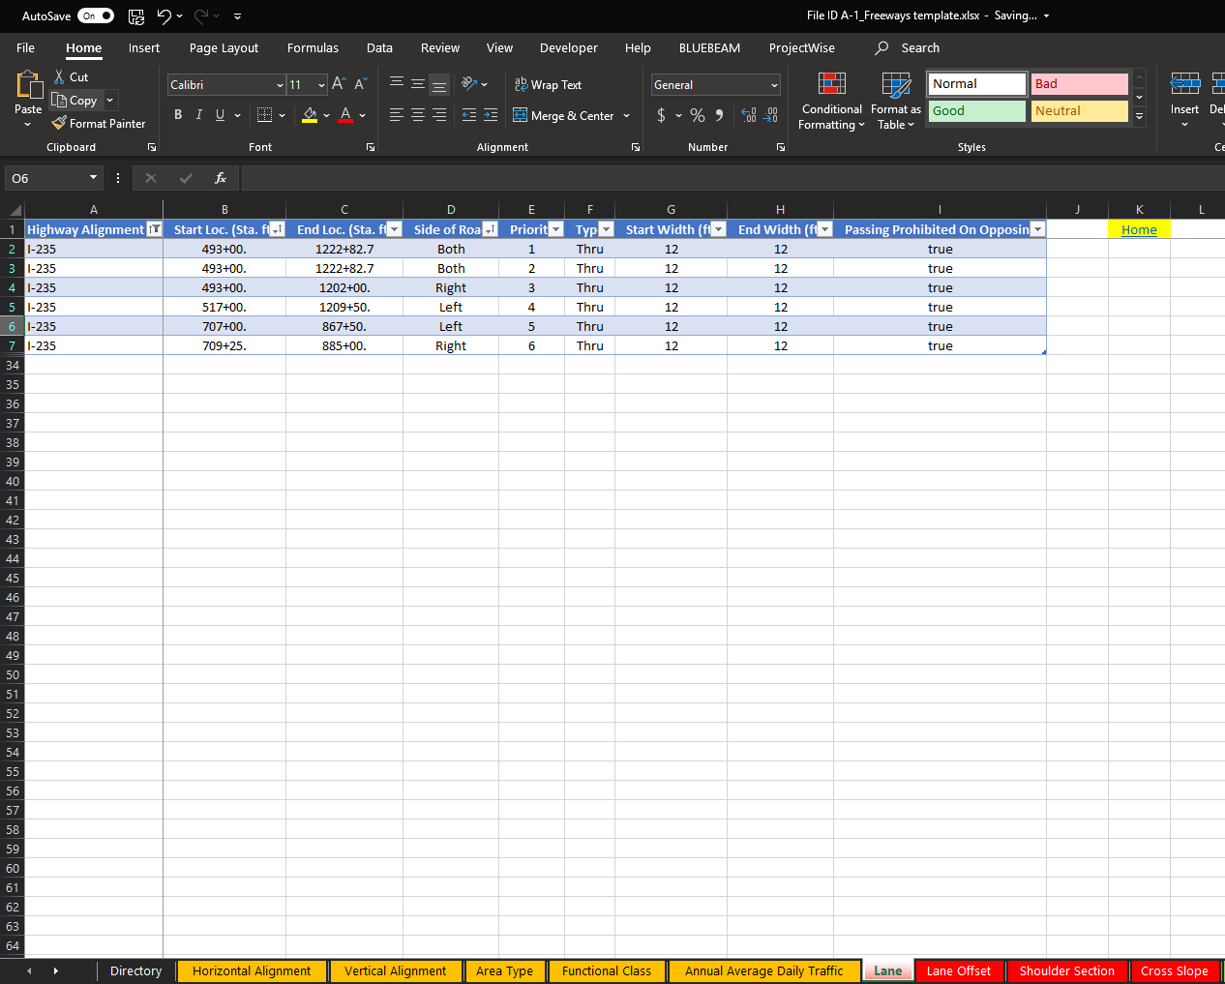

#### Links to DCT Spreadsheets

The DCT spreadsheets can be found [here.](https://hdrinc.sharepoint.com/:f:/r/teams/TrafficSafetyPracticeGroup/Shared%20Documents/5.%20Tools%20%26%20Spreadsheets/IHSDM%20Optimization%20App/DCT%20Spreadsheets?csf=1&web=1&e=qGwFHP)

Note the “File ID A-4_Ramp Terminals_DCT Spreadsheet” and “File ID A-5_Arterial Intersections_DCT Spreadsheet” files cannot be imported into IHSDM using the “Import Data” module (Section 3.3). Data for ramp terminals and arterial intersections must be entered into IHSDM manually.

## Importing Data

Back to User Manual directory

Once model data has been collected in the DCT spreadsheets (Section 3.1.1), CAD alignments, if used, are then imported into IHSDM. The imported CAD alignments create elements for evaluation. If CAD alignments are not used, elements would be created manually in IHSDM.

Figure 7 shows a workflow for importing CAD alignments to IHSDM and using the “Import Data” module in IOA.

If an arterial network is being modeled, import the arterial CAD alignments to IHSDM, then use the “Import Data” module in IOA to import arterial data from the DCT spreadsheet into the IHSDM arterial elements. Then continue to the “Batch Evaluation” module in IOA (Section 3.5).

If a freeway network is being modeled, import the freeway CAD alignments to IHSDM, then use the “Import Data” module in IOA to import freeway data from the DCT spreadsheet into the IHSDM freeway elements. If ramps are included in the model, interchange elements are recommended. Creating interchanges for ramps and ramp terminals increases the speed of evaluations in IHSDM and improves the organization of the models. To create interchange elements in IHSDM, arterial crossroads are required. Import the arterial crossroad CAD alignments. If the arterial crossroads are being evaluated, use the “Import Data” module in IOA to import the arterial data from the DCT spreadsheet into the IHSDM arterial elements. Then create the interchange elements in IHSDM, using the freeway and arterial crossroad alignments. Import the ramp CAD alignments to the associated interchange elements in IHSDM. Then use the “Import Data” module in IOA to import ramp data from the DCT spreadsheet into the IHSDM ramp elements. Finally, continue to the “Export Horizontal Curve Data” module in IOA (Section 3.4)

Figure 7. Workflow of Importing CAD Alignments in IHSDM and Using the “Data Import” Module in IOA

### The “Import Data” Module

This module takes data collected in the DCT spreadsheets and imports them into the IHSDM elements (Figure 7). Data for the elements in IHSDM are stored in XML files in the project node directory. This module bypasses the IHSDM graphical user interface and directly interacts with the XML data files.[4]

To run the module, the user uploads a DCT spreadsheet, uploads an Excel file specifying which data attributes to import, and selects the IHSDM project folder, then the module imports the data into the IHSDM elements.

Note that once this module is used to import data, IHSDM must be closed and restarted because there is no “refresh” button. Once IHSDM is restarted, the changes can be seen.

At this time, for freeways and ramps, the “Weaving Section” and “Ramp Connection” data in the DCT spreadsheets cannot be imported. The user must manually copy/paste data from these tabs into IHSDM, if applicable.

At this time, data cannot be imported for ramp terminals and arterial intersections. Data for these elements must be transferred manually from the DCT spreadsheets to IHSDM.

A video tutorial of the module can be found here [here.](https://hdrinc.sharepoint.com/:f:/r/teams/TrafficSafetyPracticeGroup/Shared%20Documents/5.%20Tools%20%26%20Spreadsheets/IHSDM%20Optimization%20App/Video%20Tutorials?csf=1&web=1&e=0Dg4V1) Please allow 30-60 seconds for the video to load.

Figure 8. The “Import Data” Module

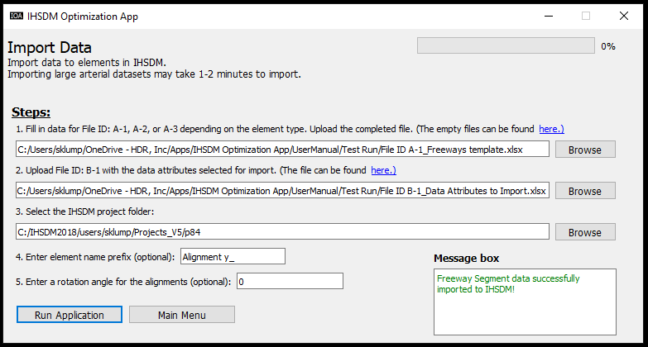

Recall that the DCT spreadsheets are formatted with the same column names and data types as the data in IHSDM. In this module, data are imported into IHSDM exactly as they appear in the DCT spreadsheets. For example, Figure 8 shows how median barrier data (note active tab name) for I-235 is transferred from the DCT spreadsheet to the corresponding IHSDM element.

Figure 9. DCT Spreadsheet Data to Imported IHSDM Element

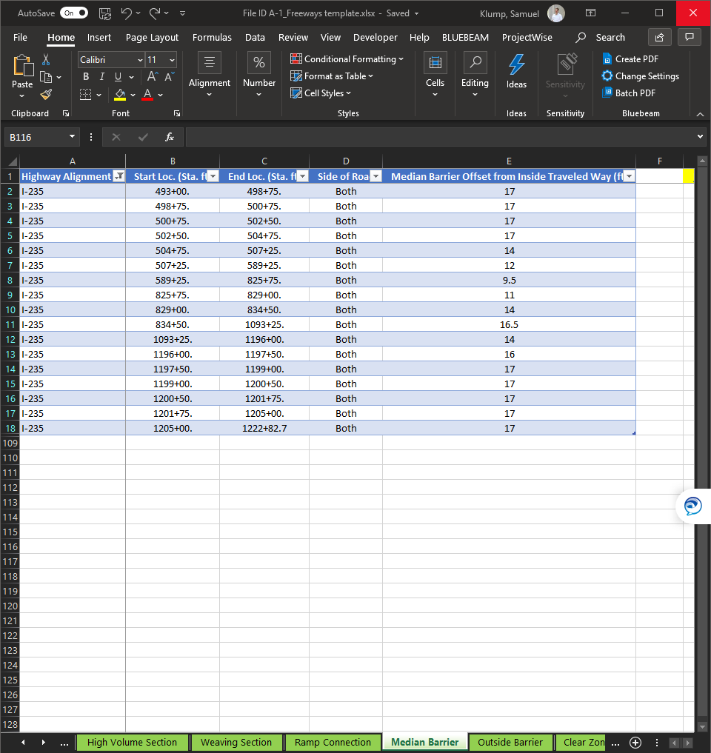

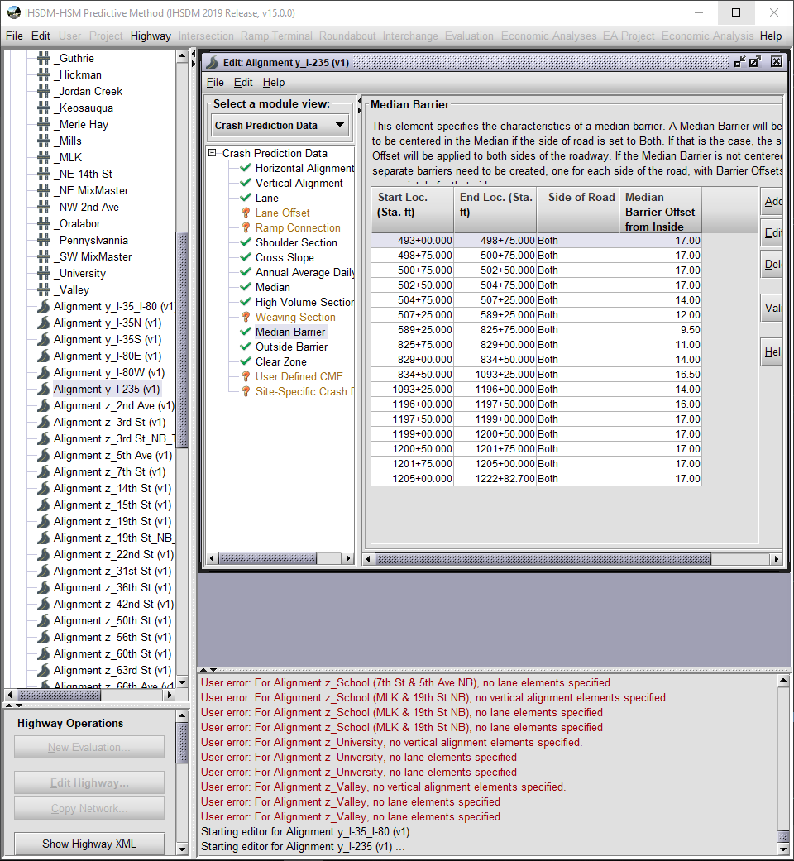

#### Step 1: Upload a DCT Spreadsheet

In Step 1, upload a DCT spreadsheet to IOA. The DCT spreadsheet for freeways, ramps, or arterials may be selected.

The files (File ID: A-1, A-2, or A-3) can be downloaded [here.](https://hdrinc.sharepoint.com/:f:/r/teams/TrafficSafetyPracticeGroup/Shared%20Documents/5.%20Tools%20%26%20Spreadsheets/IHSDM%20Optimization%20App/DCT%20Spreadsheets?csf=1&web=1&e=GvrIIE)

#### Step 2: Upload File for Selected Data Attributes to Import

Users may want to only import certain data attributes, as opposed to importing all data from a DCT spreadsheet. In Step 2, upload a file specifying which data attributes to import. If all data from the DCT spreadsheet are to be imported, type “All” in the table, as in the left snip in Figure 9. If multiple attributes are to be imported, select attributes from the drop-down in the table, as in the right snip in Figure 9.

The file (File ID: B-1) can be downloaded [here.](https://hdrinc.sharepoint.com/:f:/r/teams/TrafficSafetyPracticeGroup/Shared%20Documents/5.%20Tools%20%26%20Spreadsheets/IHSDM%20Optimization%20App/IOA_Module1_Import%20Data_Files?csf=1&web=1&e=AJWMCl)

Figure 10. Selected Data Attributes to Import File (File ID: B-1)

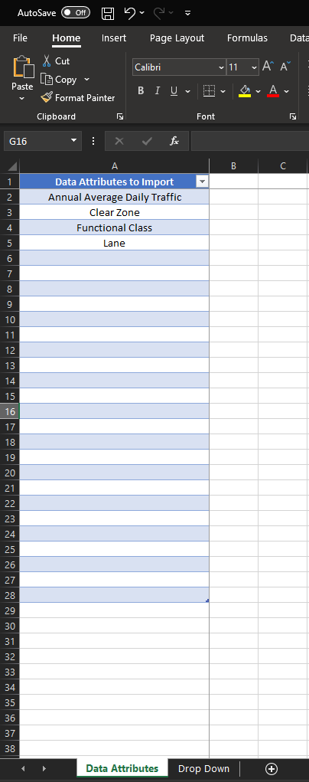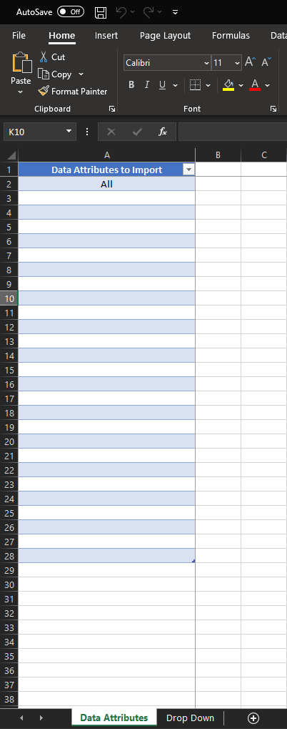

#### Step 3: Select IHSDM Project Folder

The program needs to know where to search for the IHSDM alignment files. To get the path of the IHSDM project folder, right-click on the project in IHSDM and click “Show Node Directory” (Figure 13). A File Explorer window will open. Copy the folder path. Click “Browse” in the app and paste the project folder path to complete Step 3.

Figure 11. Selecting the IHSDM Project Folder

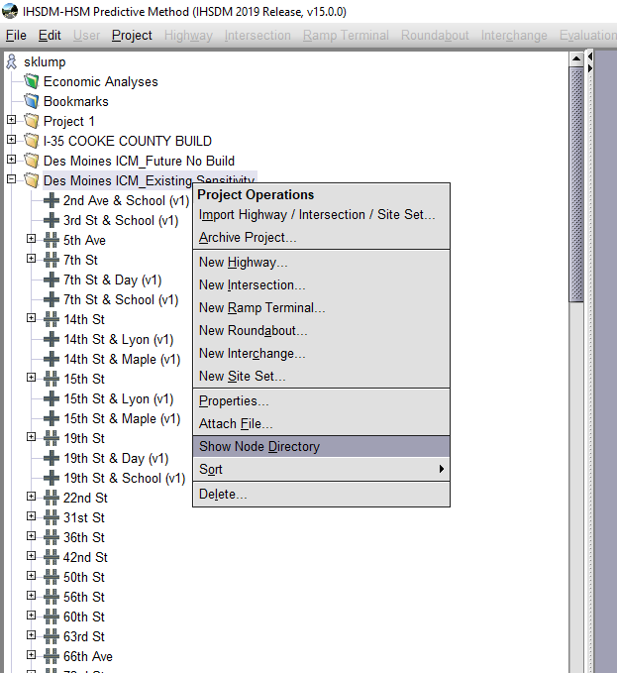

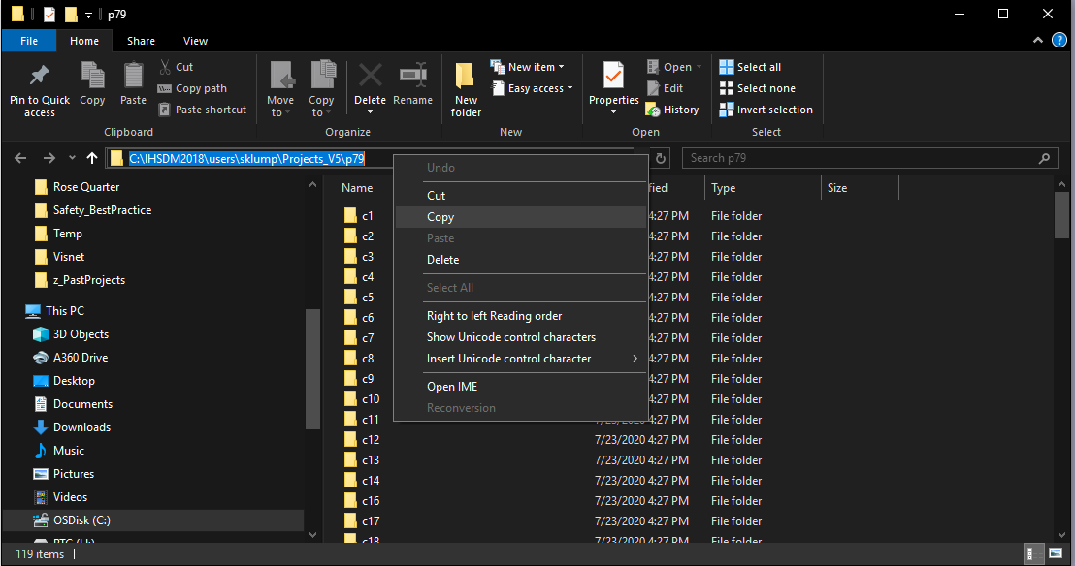

#### Step 4: Enter the Element Name Prefix (Optional)

When importing CAD alignments into IHSDM, “Alignment ” gets automatically added as a prefix to the alignment names (Figure 8). However, many users prefer to drop this name prefix in their spreadsheet data as it can be cumbersome. This step addresses the possibility of discrepancy between the names of IHSDM elements (e.g., “Alignment 5th Ave_NB Entrance”) and the alignment names in spreadsheets (e.g., “5th Ave_NB Entrance”).

If there is an element name prefix in the IHSDM elements, type it into Step 4. If CAD alignments were imported, most users will need to type in “Alignment ” (space after “Alignment” is needed) for step 4.

Figure 12. Element Name Prefix

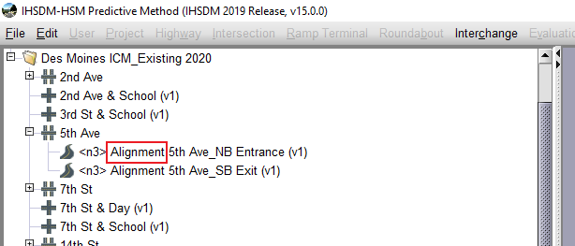

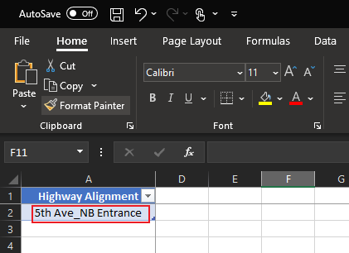

#### Step 5: Enter Rotation Angle for Alignments (Optional)

When importing CAD alignments, IHSDM may inadvertently rotate the alignments. The rotation does not affect any crash prediction outputs but is purely cosmetic. Elements may be viewed in IHSDM by right-clicking any element and clicking “View Highway”. The first snip in Figure 12 shows an imported CAD alignment that IHSDM mistakenly rotated. In Step 5, enter an angle for rotating alignments, if desired. The angle is in the clockwise direction. The second snip in Figure 12 shows the same alignment after being rotated 90 degrees using the “Import Data” module in IOA.

Figure 13. Rotate Alignments by 90 Degrees using “Import Data” Module in IOA

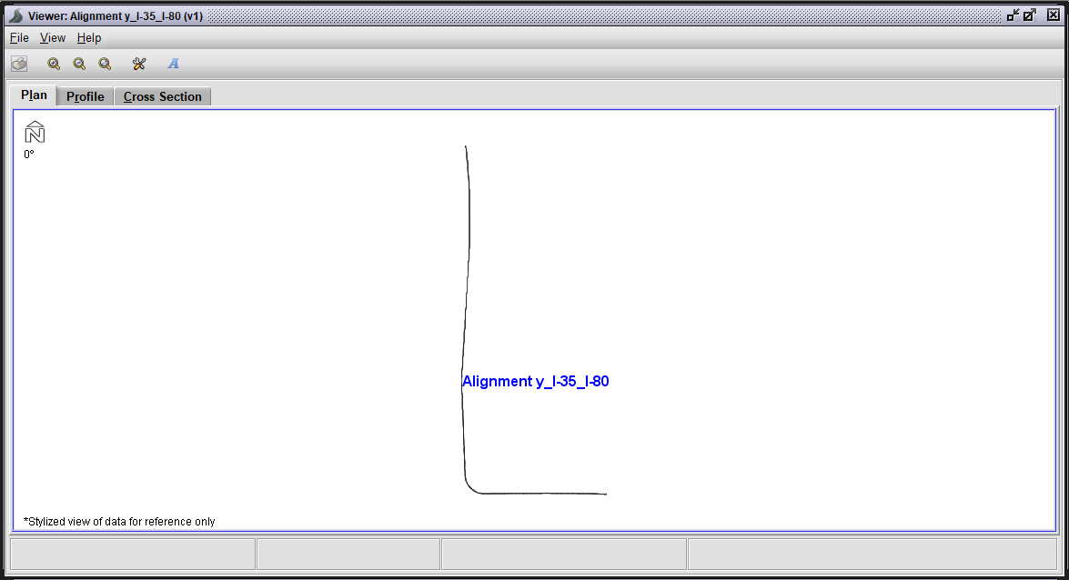

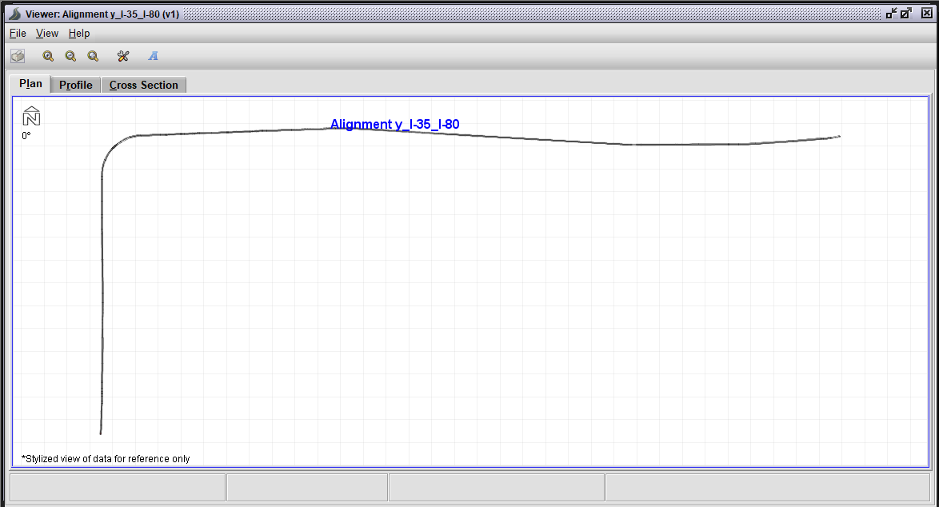

#### Verifying Data Import

Once the data are imported, IHSDM must be restarted to see changes. Verify the data import was successful by right-clicking elements and clicking “Edit Highway” to view the data. Manually check a few elements of each element type. For example, if freeway and ramps are being modeled, check a few freeway elements and a few ramp elements.

## Exporting Horizontal Curve Data from CAD Alignments

Back to User Manual directory

In IHSDM, horizontal alignment data may be manually entered or CAD alignments may be imported. If CAD alignments are used, it is desirable for analysis purposes to get the horizontal alignment data copied out of IHSDM and placed in a spreadsheet.

### The “Export Horizontal Curve Data from CAD Alignments” module

This module (Figure 5) allows users to export the horizontal alignment data from CAD alignments (imported into IHSDM) into spreadsheets. This allows analysis of horizontal curvature, which is an adjustment factor in the freeway segment and ramp HSM models. Once the horizontal alignment data are in a spreadsheet, the modeler can answer questions such as “which freeway segments have horizontal curvature in the top quintile of my network?” Similar analyses are not possible if the horizontal curve data are only stored in IHSDM.

Similar to the “Data Import” module (Section 3.3), this module works by interacting directly with the XML files in the project node directory.[5]

The module creates an Excel spreadsheet file named “Export_CurveData.xlsx” in the user-specified save location.

Figure 14. The “Export Horizontal Curve Data from CAD Alignments” module

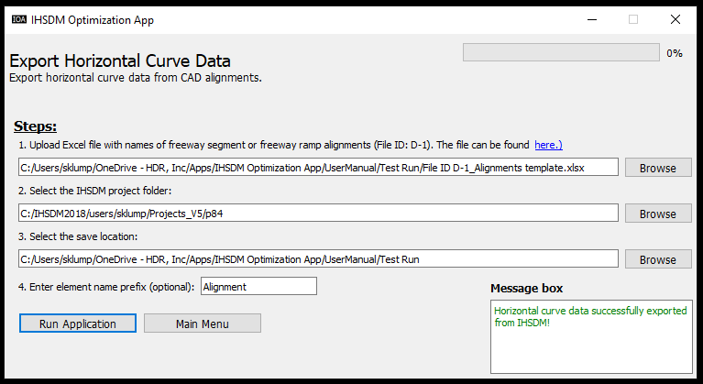

#### Step 1: Upload Excel File with Alignment Names

In Step 1, upload an Excel file with the alignment names for the desired exported horizontal alignment data. The program will search for these alignment names in the IHSDM project folder when exporting the data. This file (File ID: D-1) is a one-column table with the header name “Highway Alignment” and can be downloaded [here.](https://hdrinc.sharepoint.com/:f:/r/teams/TrafficSafetyPracticeGroup/Shared%20Documents/5.%20Tools%20%26%20Spreadsheets/IHSDM%20Optimization%20App/IOA_Module2_Export%20Horizontal%20Curve%20Data_Files?csf=1&web=1&e=8NTmyj)

Type or copy-paste (as values) the alignment names in the Excel table, as shown in Figure 6. Click “Browse” and select the alignment names file to complete Step 1.

Figure 15. Excel File with Alignment Names (File ID: D-1)

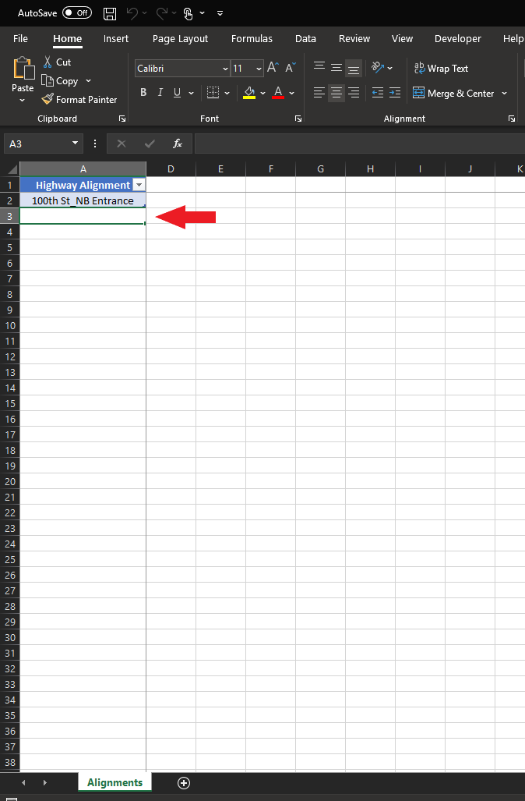

#### Step 2: Select the IHSDM Project Folder

Once the alignment names are uploaded (Step 1), the program needs to know where to search for the IHSDM alignment files. To get the path of the IHSDM project folder, right-click on the project in IHSDM and click “Show Node Directory” (Figure 7). A File Explorer window will open. Copy the folder path. Click “Browse” in the app and paste the project folder path to complete Step 2.

Figure 16. Selecting the IHSDM Project Folder





#### Step 3: Select the Save Location

This step prompts the user where they would like to save the output spreadsheet file. Click “Browse” and select a folder location.

#### Step 4: Enter the Element Name Prefix (Optional)

When importing CAD alignments into IHSDM, “Alignment ” gets automatically added as a prefix to the alignment names (Figure 8). However, many users prefer to drop this name prefix in their spreadsheet data as it can be cumbersome. This step addresses the possibility of discrepancy between the names of IHSDM elements (e.g., “Alignment 5th Ave_NB Entrance”) and the alignment names in spreadsheets (e.g., “5th Ave_NB Entrance”).

If there is an element name prefix in the IHSDM elements, type it into Step 4. If CAD alignments were imported, most users will need to type in “Alignment ” (space after “Alignment” is needed) for step 4.

Figure 17. Element Name Prefix





## Evaluating Elements

Back to User Manual directory

After data are imported into IHSDM elements, the elements can be evaluated. For large networks, this can be a time-consuming and tedious process, as the evaluation workflow must be clicked through for each element one at a time.

### The “Batch Evaluation” Module

This module takes control of the user’s mouse and keyboard (through a technique called “GUI Automation”[6]) and proceeds through the evaluation windows for the elements without the need for a human operator. IOA is looking on the computer screen for buttons just like a human would do, only responding to exact RGB values for the image recognition. This means it is important to follow the set-up guidelines for the module to run successfully.

The module may run successfully for some users right away. However, if the module does not run as intended, snips for buttons on your screen will likely need to be taken to replace the default snips. The module looks for the snips, and RGB values may vary slightly from one user’s monitor to another. If any issues arise, email Sam Klump at [samuel.klump@hdrinc.com](mailto:samuel.klump@hdrinc.com) for guidance on the re-snipping process. It only takes a few minutes and needs to be done only once for each computer.

Because the user’s mouse and keyboard are controlled by the app, the user cannot operate their computer while the module is running. Users may choose to “supervise” the module or run the module during lunch or at the end of the workday.

If the user wishes to take back control of their mouse and keyboard from IOA at any point, press “ctrl+alt+delete” to pull up the blue screen, wait a few seconds, and click “cancel”. This will stop the module and prompt a message in the IOA message box.

A video tutorial of the module can be found here [here.](https://hdrinc.sharepoint.com/:f:/r/teams/TrafficSafetyPracticeGroup/Shared%20Documents/5.%20Tools%20%26%20Spreadsheets/IHSDM%20Optimization%20App/Video%20Tutorials?csf=1&web=1&e=0Dg4V1) Please allow 30-60 seconds for the video to load.

#### Setting Up the IHSDM Screen for the Module

There are four requirements for the module to run successfully:

1. The IHSDM window must be on the user’s main display screen. To check which screen is the main (if multiple monitors are used), type “display” in the Windows icon to pull up the display settings (Figure 18).

Figure 18. Windows Display Settings for Main Display

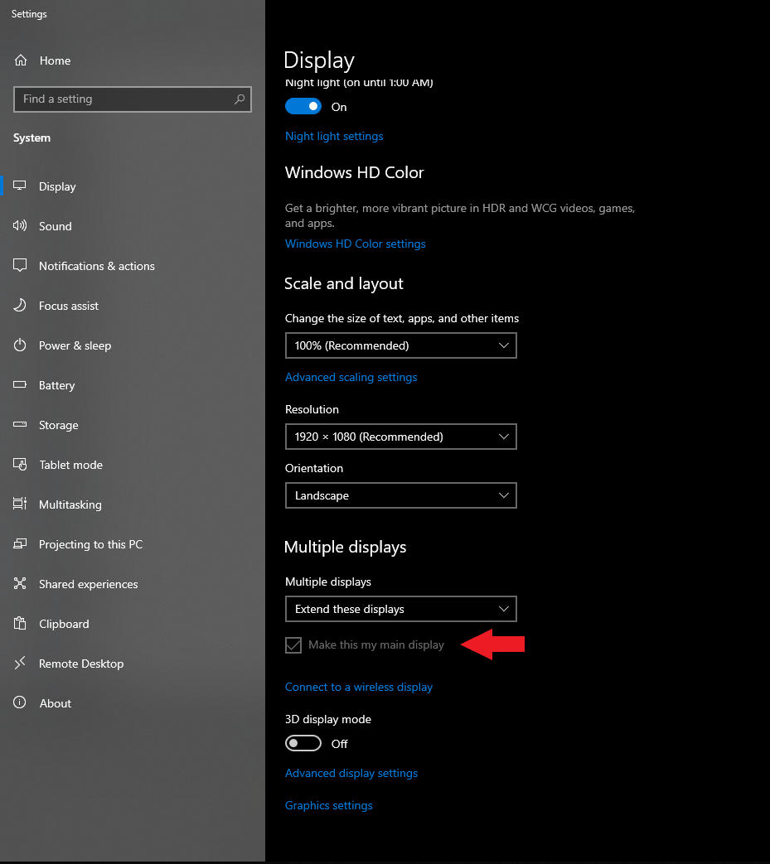

1. Make sure there are no other application windows in front of the IHSDM window. Make sure the IHSDM window is maximized. Note after opening IHSDM, the window is not automatically maximized and is often slightly offset (Figure 19).

Figure 19. IHSDM Window Maximized with No Other Windows in Front

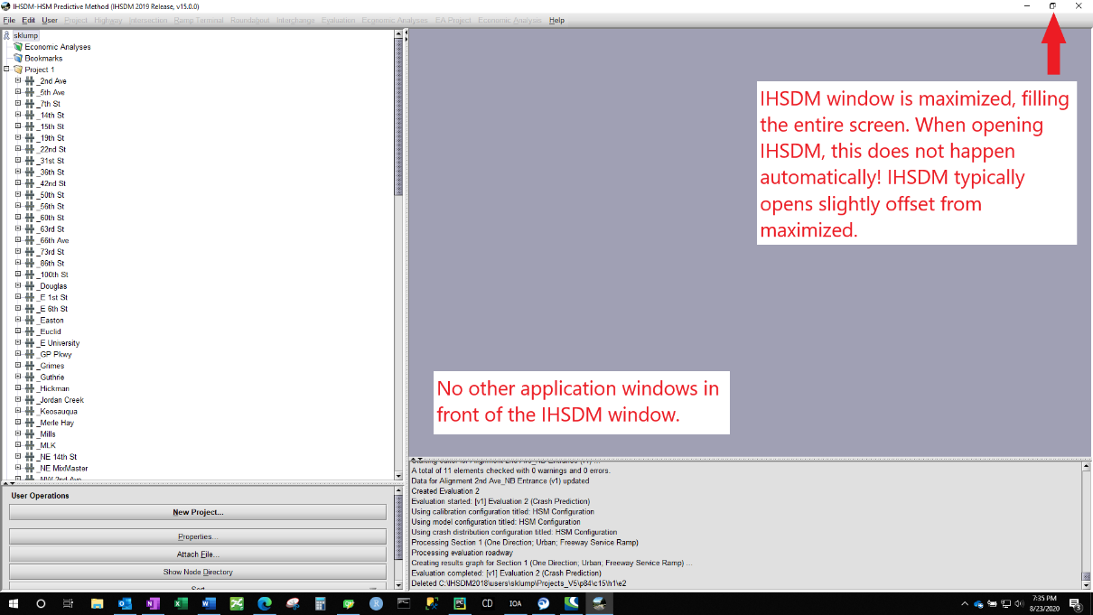

1. The module can only evaluate elements in immediate view when the “Run Application” button is clicked. Maximize the view of the left pane that shows the elements. In Figure 20, the configuration in the bottom snip will allow more elements to be evaluated than the configuration in the top snip.

Figure 20. Only Elements in Immediate View Can Be Evaluated

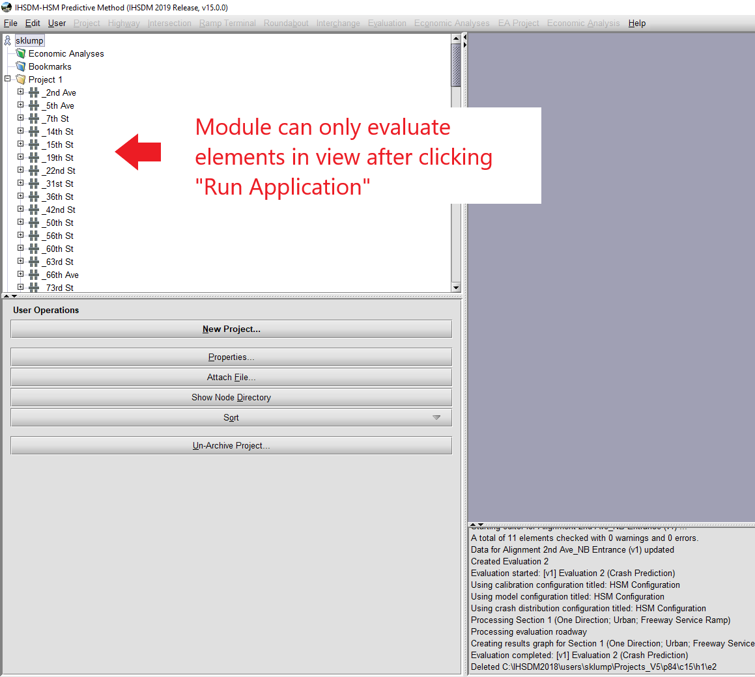

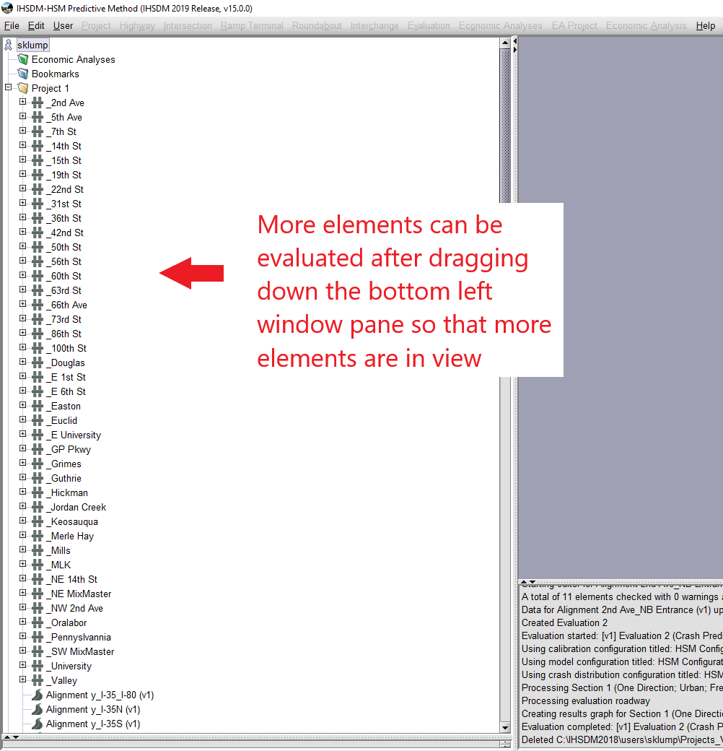

1. Make sure none of the elements that are to be evaluated are selected. If an element is selected when the module runs, it may not detect it as an element. In Figure 21, in the top snip, the highlighted/selected element may not be evaluated. In the bottom snip, because no elements are highlighted/selected, all elements will be evaluated.

Figure 21. Make Sure Elements Not Selected When Running Module

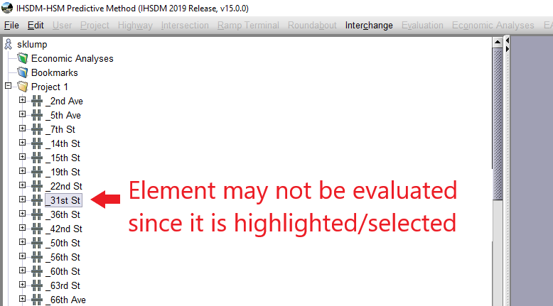

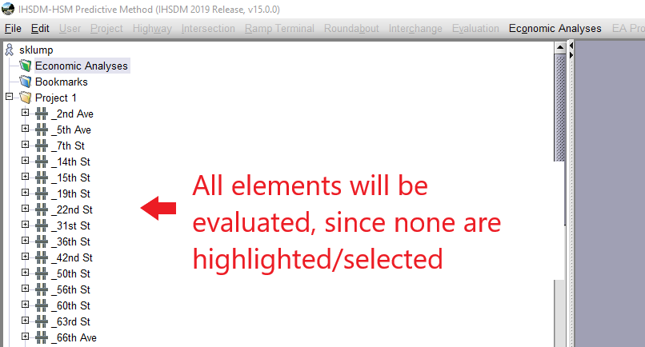

#### Step 1: Select the Type of Element to Evaluate

In Step 1, select the type of element to evaluate (Figure 21). The first option evaluates segments for freeways and arterials. The second option is for interchanges, which evaluates ramps and ramp terminals that are stored in interchanges.

Figure 22. Select Type of Element to Evaluate

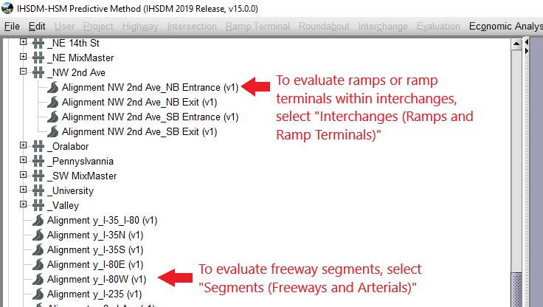

#### Step 2: Select Type of Output to Save

In IHSDM, crash prediction outputs can be created as HTML files or as PDFs. In Step 2, select the type of prediction output to be saved. Note that while HTML files can be parsed into Excel files (“Parse HTML” module, Section 3.6), PDF files cannot be parsed with IOA. As such, it is recommended to select either “HTML Only” or “HTML and PDF”.

#### Step 3: Select Whether to Keep or Delete Evaluations out of IHSDM

In Step 3, select whether to keep evaluations in IHSDM or delete them. Some users may prefer to delete them to keep IHSDM as clean as possible. With the crash prediction output saved, there may be no further need for the evaluation.

#### Step 4: Select Folder in which to Save the Evaluation Outputs

In Step 4, select the folder in which to save the HTML or PDF evaluation outputs.

#### Step 5: Enter Index of First Element to Evaluate

In Step 5, enter the index of the first element to evaluate. Users may not wish to evaluate all elements in view. For example, in Figure 23, to make elements in the “_2nd Ave” interchange the first to be evaluated, enter “1” as the index in Step 5. To start with evaluating the “_15th St” interchange, enter “5” as the index.

This module evaluates elements from top-to-down. This means if “1” was entered as the index, the module would evaluate the “_2nd Ave” interchange and proceed subsequently to the next interchanges below it.

Figure 23. Index of First Element to Evaluate

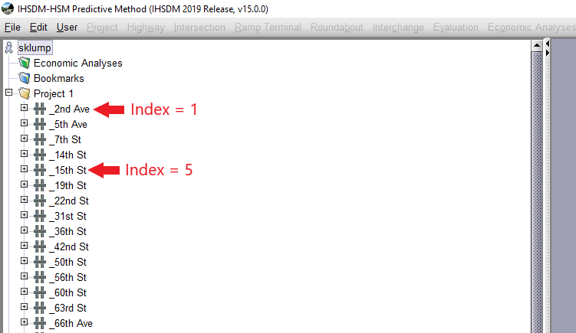

#### Step 6: Enter the Number of Elements to Evaluate

In Step 6, enter the number of elements to evaluate. The module will start evaluating elements according to the index specified in Step 5, then continue evaluating elements below it until the number of elements entered in Step 6 has been evaluated.

#### Step 7: Enter the Start Year for the Evaluations

In Step 7, enter the start year for the evaluations.

#### Step 8: Enter the End Year for the Evaluations

In Step 8, enter the end year for the evaluations.

#### Step 9: Enter the Element Name Prefix (Optional)

When importing CAD alignments into IHSDM, “Alignment ” gets automatically added as a prefix to the alignment names (Figure 24). Without specifying the element name prefix, the HTML or PDF files would be saved with the same name as the element in IHSDM (e.g., “Alignment 5th Ave_NB Entrance”). Users may wish to drop the “Alignment ” prefix in the saved file names. If “Alignment ” is entered as the prefix in Step 9, the HTML or PDF file would be saved as “5th Ave_NB Entrance”.

If there is an element name prefix in the IHSDM elements, type it into Step 9. If CAD alignments were imported, most users will need to type in “Alignment ” (space after “Alignment” is needed) for step 9.

Figure 24. Element Name Prefix





#### Module Output

Once the module is done running, check that the HTML or PDF outputs were saved in the save location selected in Step 4 (Figure 25).

Figure 25. HTML or PDF Outputs Saved in Selected Folder After Batch Evaluation Complete

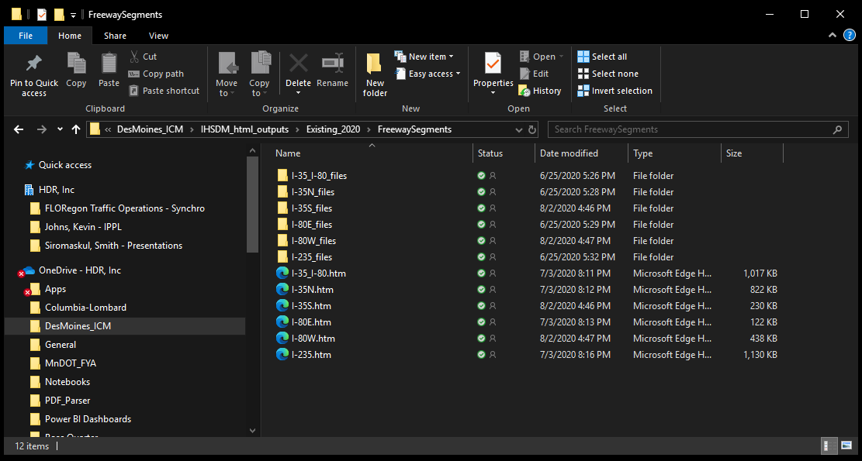

## Parsing HTML Evaluation Results

Back to User Manual directory

Crash predictions can be viewed in the HTML outputs, however, they cannot be directly analyzed. It is desirable to extract the data from the HTML outputs and copy/synthesize them into an Excel spreadsheet, where the entire suite of Excel analysis tools can be used. Because the parsed files are standardized and the format does not change, the Excel spreadsheets can also be imported into Power BI dashboard templates for seamless visualization and analysis.

### The “Parse HTML Results” Module

This module scrapes data from the individual HTML crash prediction output files and synthesizes them into a combined Excel spreadsheet (Figure 26). For example, this module can take 150 HTML ramp crash output files and combine the data into a single Excel file.

A video tutorial of the module can be found here [here.](https://hdrinc.sharepoint.com/:f:/r/teams/TrafficSafetyPracticeGroup/Shared%20Documents/5.%20Tools%20%26%20Spreadsheets/IHSDM%20Optimization%20App/Video%20Tutorials?csf=1&web=1&e=0Dg4V1) Please allow 30-60 seconds for the video to load.

Figure 26. The “Parse HTML Results” Module

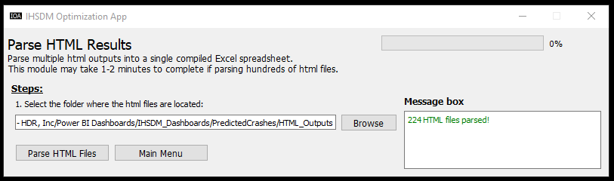

A separate Excel file is created for different element types. The names of the produced Excel files are as follows:

* Freeway segments: “parsed_freewaysegment.xlsx”
* Ramps: “parsed_freewayramp.xlsx”
* Ramp terminals: “parsed_rampterminal.xlsx”
* Arterials: “parsed_arterialsegment.xlsx”

The HTML files can all be in the same folder, even if there are different element types. The module detects what element type each HTML file is and assigns the data to the correct Excel file. This means this module should only need to be run once for each scenario, if multiple scenarios are evaluated (e.g., Existing, No Build, Build).

Within each parsed Excel file, each tab corresponds to a table in the HTML file. Figure 27 shows an HTML file that is parsed into an Exel file for the I-235 freeway segment. All tables in the HTML files are included in the parsed Excel files.

Figure 27. Each Table in HTML Files is a Tab in Parsed Excel File

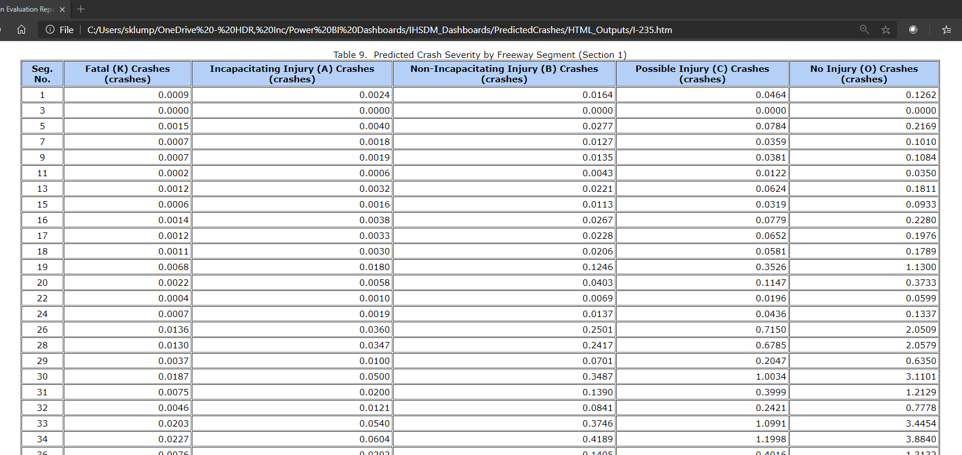

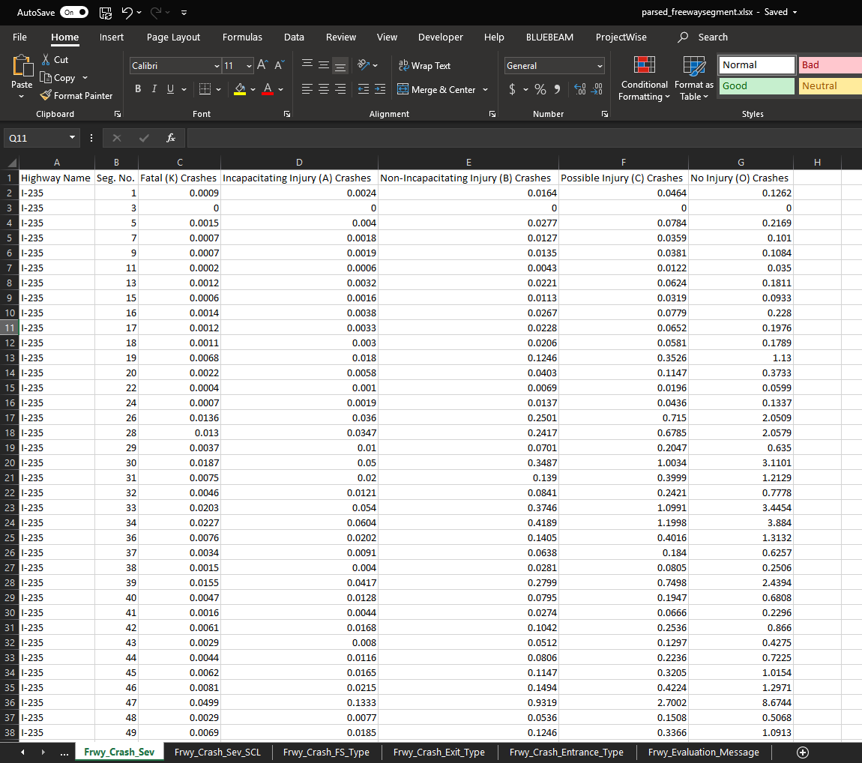

#### Step 1: Select the Folder Where the HTML Files Are Located

Select where the HTML files are located. The parsed Excel files are saved in this same folder (Figure 28).

Figure 28. Parsed Excel Files Created in the Same Folder as the HTML Files

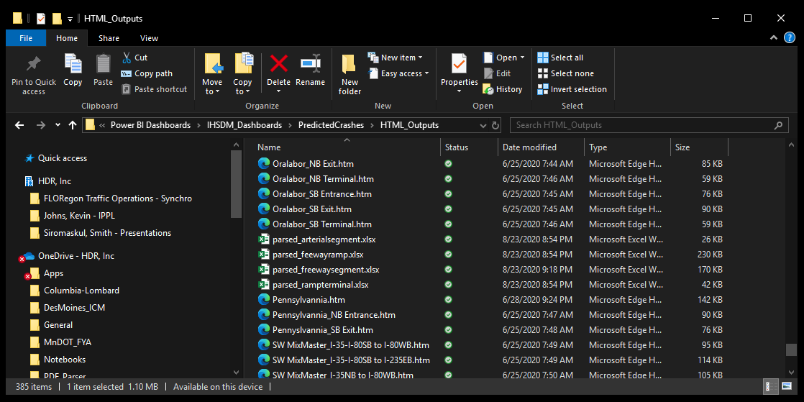

## Analyzing Data by Segments for Freeways, Ramps, and Arterials

Back to User Manual directory

Predictive safety models consist of both model inputs and crash prediction outputs, and both are important to deliver the most effective actionable insights. For freeways, ramps, and arterial segments, this may require analyzing inputs and outputs by defined segments. Though IHSDM creates homogeneous segments, these segments may vary widely in length and may not be useful for comparing, for example, crash frequency between segments. For freeways, more useful segments may be gore-point-to-gore-point at interchanges. If the analyst wanted to know how many crashes occurred from a gore-point-to-gore-point segment, they would need to sum up crashes for each IHSDM homogenous segment located between the gore points.

For data inputs, the analyst would need to calculate length-weighted averages from the DCT spreadsheets for each input in the segment. For example, the outside shoulder width may vary within the gore-point-to-gore-point segment and Excel equations would be needed to calculate the average outside shoulder width, weighted by the length within the segment.

Note that ramp terminal and arterial intersection data cannot be segmented.

### The “Segment Analysis for Freeways, Ramps, and Arterials” Module

This module calculates crash prediction outputs and length-weighted average inputs for user-defined segments (Figure 28). The user uploads a DCT spreadsheet, a crash output file from the “Parse HTML” module (Section 3.6), and a user-defined segmentation file, then the module outputs an Excel file of the length-weighted average model inputs and summed crash outputs, according to the user-defined segments.

Figure 29. The “Segment Analysis for Freeways, Ramps, and Arterials” Module

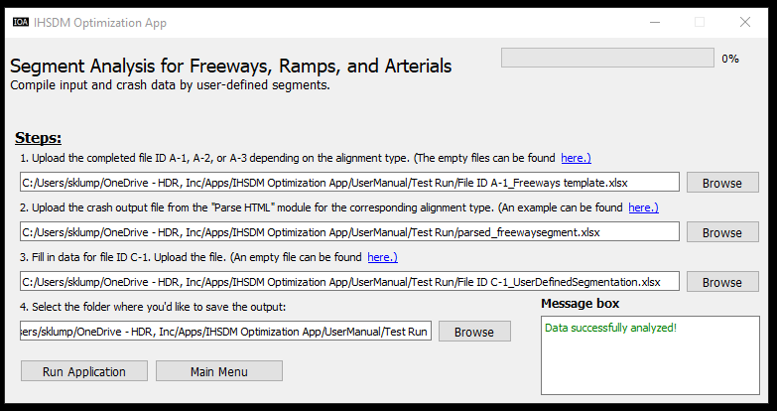

#### Step 1: Upload a DCT Spreadsheet

In Step 1, upload a DCT spreadsheet to IOA. The DCT spreadsheet for freeways, ramps, or arterials may be selected.

The files (File ID: A-1, A-2, or A-3) can be downloaded [here.](https://hdrinc.sharepoint.com/:f:/r/teams/TrafficSafetyPracticeGroup/Shared%20Documents/5.%20Tools%20%26%20Spreadsheets/IHSDM%20Optimization%20App/DCT%20Spreadsheets?csf=1&web=1&e=ktSYPB)

#### Step 2: Upload a Crash Output File from the “Parse HTML” Module

In Step 2, upload a predicted crash output file from the “Parse HTML” module IOA. The crash output file has one of the following names:

* Freeway segments: “parsed_freewaysegment.xlsx”
* Ramps: “parsed_freewayramp.xlsx”
* Arterials: “parsed_arterialsegment.xlsx”

For more on the crash output file, see Section 3.6.

#### Step 3: Upload a User-Defined Segmentation File

In Step 3, upload a defined segmentation file, for which an empty template can be found [here](https://hdrinc.sharepoint.com/:f:/r/teams/TrafficSafetyPracticeGroup/Shared%20Documents/5.%20Tools%20%26%20Spreadsheets/IHSDM%20Optimization%20App/IOA_Module5_Segment%20Analysis%20for%20Freeways,%20Ramps,%20and%20Arterials_Files?csf=1&web=1&e=QCe0PE) (File ID: C-1). In the first column, “Highway Name”, enter the IHSDM element name (e.g., “I-235”). In the second column, “Segment Name”, enter any name to designate the segment as. In the third and fourth columns, “Start Station” and “End Station”, enter the limits of the segment.

If specifying segments for a freeway, match the segment limits up with the IHSDM homogeneous segment limits. For example, Figure 29 shows the user segmentation file (File ID: C-1) and the IHSDM homogenous segments for the I-80W freeway. Notice the start and end stations in the user segmentation file correspond with start and end stations in the IHSDM segments (with circumscribed red squares in the figure). Though the same station limits must exist in the user segmentation and the IHSDM segments, the segments are not one-for-one. The first user segment, Station 200+00 to 233+00, includes six IHSDM segments.

Figure 30. User-Defined Segmentation File

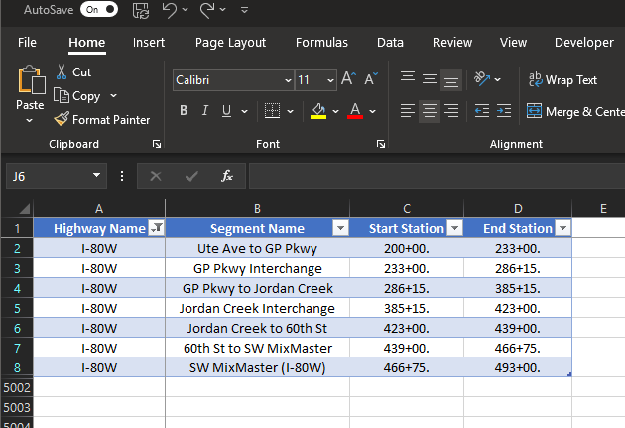

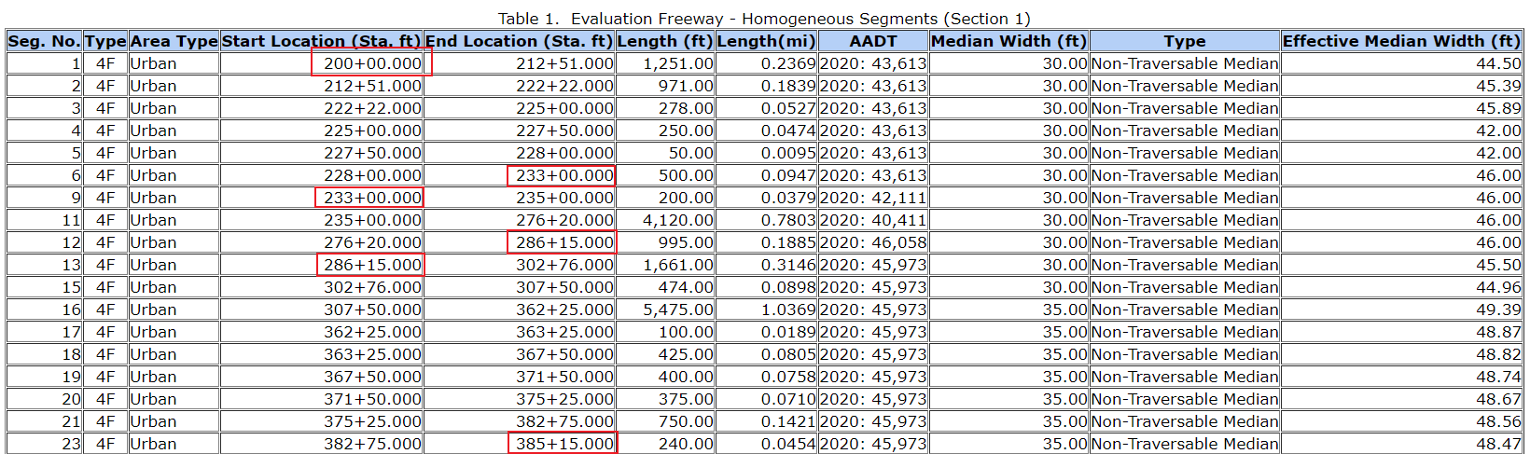

#### Step 4: Select the Save Location

In Step 4, select where to save the output spreadsheet file. Click “Browse” and select a folder location.

The segment analysis file is created in the save location (Figure 30). Depending on the element type, the names of the analysis files are:

* Freeways: “Freeway_SegmentAnalysis.xlsx”
* Ramps: “Ramp_SegmentAnalysis.xlsx”
* Arterials: “Arterial_SegmentAnalysis.xlsx”

Figure 31. Output of “Segment Analysis for Freeways, Ramps, and Arterials” Module

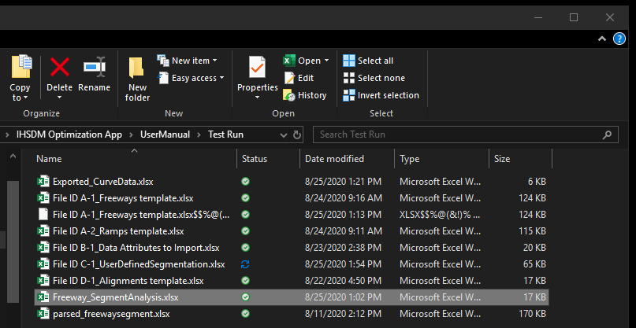

# Predictive Safety Analysis with Power BI Dashboards

In Section 3, a process was described in which data collected in the DCT spreadsheets (Section 3.2) was fed into IHSDM and produced crash prediction outputs in an Excel format (Section 3.6). With standardized prediction outputs in Excel spreadsheets, Power BI dashboard templates were developed for seamless data import, data visualization, and on-the-fly data analysis.

## Overview

Power BI dashboard templates available for use are shown in Table 2.

Table 2. Power BI Dashboard Templates

| **Dashboard Name** | **Description** | **Link to in Sharepoint Site** |
| --- | --- | --- |
| **Alternatives Comparison** | - Compares crash frequencies, severities, rates, and costs for the entire network between existing, no build, and build models | [Alternatives Comparison](https://hdrinc.sharepoint.com/:u:/r/teams/TrafficSafetyPracticeGroup/Shared%20Documents/5.%20Tools%20%26%20Spreadsheets/IHSDM%20Optimization%20App/Power%20BI%20Dashboards/Alternatives%20Comparison.zip?csf=1&web=1&e=v4NsCe) |
| **Network Wide** | - Crash frequencies, severities, types, rates, and costs for the entire network  - Individual reports for freeway segments, ramps, ramp terminals, and arterials | [Network Wide](https://hdrinc.sharepoint.com/:u:/r/teams/TrafficSafetyPracticeGroup/Shared%20Documents/5.%20Tools%20%26%20Spreadsheets/IHSDM%20Optimization%20App/Power%20BI%20Dashboards/Network%20Wide.zip?csf=1&web=1&e=j51O3r) |
| **Freeway Segments** | - Analysis of freeway segment model inputs and crash outputs, with reports for model inputs as quintiles and percentiles of the entire model  - Reports for box and whisker plots for model inputs and input data issues flagged in the IHSDM evaluation messages | [Freeway Segments](https://hdrinc.sharepoint.com/:u:/r/teams/TrafficSafetyPracticeGroup/Shared%20Documents/5.%20Tools%20%26%20Spreadsheets/IHSDM%20Optimization%20App/Power%20BI%20Dashboards/Freeway%20Segments.zip?csf=1&web=1&e=49EwZT) |
| **Freeway Ramps** | - Analysis of freeway ramp model inputs and crash outputs, with reports for model inputs as quintiles and percentiles of the entire model  - Reports for box and whisker plots for model inputs and input data issues flagged in the IHSDM evaluation messages | [Freeway Ramps](https://hdrinc.sharepoint.com/:u:/r/teams/TrafficSafetyPracticeGroup/Shared%20Documents/5.%20Tools%20%26%20Spreadsheets/IHSDM%20Optimization%20App/Power%20BI%20Dashboards/Freeway%20Ramps.zip?csf=1&web=1&e=hDANzW) |
| **Ramp Terminals** | - Analysis of ramp terminal model inputs and crash outputs  - Report for input data issues flagged in the IHSDM evaluation messages | [Ramp Terminals](https://hdrinc.sharepoint.com/:u:/r/teams/TrafficSafetyPracticeGroup/Shared%20Documents/5.%20Tools%20%26%20Spreadsheets/IHSDM%20Optimization%20App/Power%20BI%20Dashboards/Ramp%20Terminals.zip?csf=1&web=1&e=WyRw5C) |
| **Arterial Segments and Intersections** | - Analysis of arterial segment and intersection model inputs and crash outputs, with reports for segment model inputs as quintiles and percentiles of the entire model  - Reports for box and whisker plots for segment model inputs and input data issues flagged in the IHSDM evaluation messages | [Arterial Segments and Intersections](https://hdrinc.sharepoint.com/:u:/r/teams/TrafficSafetyPracticeGroup/Shared%20Documents/5.%20Tools%20%26%20Spreadsheets/IHSDM%20Optimization%20App/Power%20BI%20Dashboards/Arterial%20Segments%20and%20Intersections.zip?csf=1&web=1&e=sQM5Iw) |

The Power BI templates can be used to answer questions such as:

* “How do the total crash costs compare for the existing, no build, and build models?”
* “What are the crash frequencies, severities, rates, and costs for each facility type in the network?”
* “Which freeway segments in my network have crash rates in the top quintile?”
* “How do reduced shoulder widths change the crash type distribution on the freeway ramps?”
* “Where are there stop-controlled ramp terminals in the network and how do the crash severities, types, and rates compare to the signalized ramp terminals?”
* “For any given arterial segment, what percentiles are the median width, fixed object density, and number of driveways in?”

The templates allow for a seamless exploration of the IHSDM models, where model inputs can be analyzed in how they affect the model outputs in terms of crash frequencies, severities, types, and rates.

*Be aware that filtering for any type of model input does not necessarily indicate that model input has an independent effect on the model outputs.* For instance, if ramps are filtered to those in the bottom quintile of inside shoulder width, crash rates may increase above the median. However, the increased crash rate could be more influenced by the fact that these same ramps are also in the bottom quintile of outside shoulder width. In this case, inside shoulder width could be a proxy for outside shoulder width and false causation could arise. Filtering for multiple model inputs to find independent effects is recommended.

## Setting up the Dashboards

The dashboards are in zipped folders with the associated spreadsheet data. The dashboards have a connection built to the spreadsheets, in which the data are linked to the dashboards. The dashboards do not interact with the spreadsheet data directly, but instead, create a copy so the original data integrity is not compromised. To use each dashboard, the user simply repaths the data connections to the files for their models. The spreadsheet data currently in the zipped folders are just for examples (they use data from a different project). To use each dashboard, follow these steps:

1. Download the zipped folder in the links in Table 2
2. “Extract All...”
3. Open the Power BI dashboard file (.pbix file)
4. Go to “File”>> “Options and settings”>> “Data source settings”
5. A dialog box will open called “Data source settings”. For each file, click “Change Source…”
6. Click “Browse…” to select the corresponding file for your model data
7. Click “OK”
8. Click “Close”
9. Under the “Home” tab in the ribbon, in the “Queries” panel, click “Refresh”

Most importantly, make sure the files that are repathed have the same format as the files in the zipped folders. If the wrong file or a file with a different format is repathed, the dashboards will not work as expected.

A video tutorial of the module can be found here [here.](https://hdrinc.sharepoint.com/:f:/r/teams/TrafficSafetyPracticeGroup/Shared%20Documents/5.%20Tools%20%26%20Spreadsheets/IHSDM%20Optimization%20App/Video%20Tutorials?csf=1&web=1&e=0Dg4V1) Please allow 30-60 seconds for the video to load.

### Files for the Dashboards

This subsection details the files needed for each dashboard.

#### Alternatives Comparison

In the “Alternatives Comparison” dashboard, there are 3 subfolders: “Existing-Parsed Crash Files”, “No Build-Parsed Crash Files”, and “Build-Parsed Crash Files”. The files in each of these folders are the parsed crash files created in the “Parse HTML” module (Section 3.6), for the different alternatives.

“File ID E-1_Crash Costs” is used to calculate the crash costs. A blank file can be found [here.](https://hdrinc.sharepoint.com/:f:/r/teams/TrafficSafetyPracticeGroup/Shared%20Documents/5.%20Tools%20%26%20Spreadsheets/IHSDM%20Optimization%20App/Power%20BI%20Dashboards?csf=1&web=1&e=ApkVcx)

#### Network Wide

In the “Network Wide’ dashboard, the “parsed_freewaysegment”, “parsed_freewayramp”, “parsed_rampterminal”, and “parsed_arterialsegment” files are the parsed crash files created in the “Parse HTML” module (Section 3.6).

“File ID E-1_Crash Costs” is used to calculate the crash costs. A blank file can be found [here.](https://hdrinc.sharepoint.com/:f:/r/teams/TrafficSafetyPracticeGroup/Shared%20Documents/5.%20Tools%20%26%20Spreadsheets/IHSDM%20Optimization%20App/Power%20BI%20Dashboards?csf=1&web=1&e=ApkVcx)

“File ID F-1_LatLongs” is used to display elements geospatially in the maps. In the “Name” column, enter the element names exactly as they appear in the parsed crash files. A blank file can be found [here.](https://hdrinc.sharepoint.com/:f:/r/teams/TrafficSafetyPracticeGroup/Shared%20Documents/5.%20Tools%20%26%20Spreadsheets/IHSDM%20Optimization%20App/Power%20BI%20Dashboards?csf=1&web=1&e=ApkVcx)

#### Freeway Segments

In the “Freeway Segments” dashboard, the “parsed_freewaysegment” file is the parsed crash files created in the “Parse HTML” module (Section 3.6).

The “Freeway_SegmentAnalysis” file is the file created in the “Segment Analysis for Freeways, Ramps, and Arterials” module (Section 3.7).

“File ID F-1_LatLongs” is used to display elements geospatially in the maps. In the “Name” column, enter the element names exactly as they appear in the parsed crash files. A blank file can be found [here.](https://hdrinc.sharepoint.com/:f:/r/teams/TrafficSafetyPracticeGroup/Shared%20Documents/5.%20Tools%20%26%20Spreadsheets/IHSDM%20Optimization%20App/Power%20BI%20Dashboards?csf=1&web=1&e=ApkVcx)

#### Freeway Ramps

In the “Freeway Ramps” dashboard, the “parsed_freewayramp.xlsx” file is the parsed crash files created in the “Parse HTML” module (Section 3.6).

The “Ramp_SegmentAnalysis” file is the file created in the “Segment Analysis for Freeways, Ramps, and Arterials” module (Section 3.7).

The “File ID A-2_Ramps_DCT Spreadsheet” file is the DCT spreadsheet file as described in Section 3.2, found [here](https://hdrinc.sharepoint.com/:f:/r/teams/TrafficSafetyPracticeGroup/Shared%20Documents/5.%20Tools%20%26%20Spreadsheets/IHSDM%20Optimization%20App/DCT%20Spreadsheets?csf=1&web=1&e=s0aigh).

“File ID F-1_LatLongs” is used to display elements geospatially in the maps. In the “Name” column, enter the element names exactly as they appear in the parsed crash files. A blank file can be found [here.](https://hdrinc.sharepoint.com/:f:/r/teams/TrafficSafetyPracticeGroup/Shared%20Documents/5.%20Tools%20%26%20Spreadsheets/IHSDM%20Optimization%20App/Power%20BI%20Dashboards?csf=1&web=1&e=ApkVcx)

#### Ramp Terminals

In the “Ramp Terminals” dashboard, the “parsed_rampterminal” file is the parsed crash files created in the “Parse HTML” module (Section 3.6).

The “File ID A-4_Ramp Terminals_DCT Spreadsheet” file is the DCT spreadsheet file as described in Section 3.2, found [here](https://hdrinc.sharepoint.com/:f:/r/teams/TrafficSafetyPracticeGroup/Shared%20Documents/5.%20Tools%20%26%20Spreadsheets/IHSDM%20Optimization%20App/DCT%20Spreadsheets?csf=1&web=1&e=s0aigh).

“File ID F-1_LatLongs” is used to display elements geospatially in the maps. In the “Name” column, enter the element names exactly as they appear in the parsed crash files. A blank file can be found [here.](https://hdrinc.sharepoint.com/:f:/r/teams/TrafficSafetyPracticeGroup/Shared%20Documents/5.%20Tools%20%26%20Spreadsheets/IHSDM%20Optimization%20App/Power%20BI%20Dashboards?csf=1&web=1&e=ApkVcx)

#### Arterial Segments and Intersections

In the “Arterials Segments and Intersections” dashboard, the “parsed_arterialsegment” file is the parsed crash files created in the “Parse HTML” module (Section 3.6).

The “Arterial_SegmentAnalysis” file is the file created in the “Segment Analysis for Freeways, Ramps, and Arterials” module (Section 3.7).

“File ID F-1_LatLongs” is used to display elements geospatially in the maps. In the “Name” column, enter the element names exactly as they appear in the parsed crash files. A blank file can be found [here.](https://hdrinc.sharepoint.com/:f:/r/teams/TrafficSafetyPracticeGroup/Shared%20Documents/5.%20Tools%20%26%20Spreadsheets/IHSDM%20Optimization%20App/Power%20BI%20Dashboards?csf=1&web=1&e=ApkVcx)

## Model Analysis

The dashboard files serve as templates and not necessarily final products. Users are encouraged to edit the dashboards according to their specific project needs. This can be done in the form of additional/edited calculated columns, measures, and visualizations. Many resources are available online for learning to develop Power BI dashboards

1. *Interactie Highway Safety Design Model (IHSDM): Overview*. Federal Highway Administration. Updated December 2019. <https://highways.dot.gov/research/safety/interactive-highway-safety-design-model/interactive-highway-safety-design-model-ihsdm-overview>
2. Python.org, <https://www.python.org/>
3. Qt Designer Manual: <https://doc.qt.io/qt-5/qtdesigner-manual.html>
4. The app uses the “ElementTree” package in Python for XML parsing, for which the documentation can be found here: <https://docs.python.org/3/library/xml.etree.elementtree.html>
5. The app uses the “ElementTree” package in Python for XML parsing, for which the documentation can be found here: <https://docs.python.org/3/library/xml.etree.elementtree.html>
6. This app uses the “PyAutoGUI” package in Python for GUI automation, for which documentation can be found here: <https://pyautogui.readthedocs.io/en/latest/>